**Lab: Arrays Advanced**

Submit your solutions in the SoftUni judge system at: <https://alpha.judge.softuni.org/contests/arrays-advanced-lab/1254>

## Sum First and Last

Write a function that calculates and prints the **sum** of the **first** and the **last** elements in an array.

The **input** comes as an array of string elements holding numbers.

The **output** is printed on the console.

### Examples

|  |  |
| --- | --- |
| **Input** | **Output** |
| ['20', '30', '40'] | 60 |
| ['5', '10'] | 15 |

1. **Negative or Positive Numbers**

Write a function that processes the elements in an **array** one by one and produces a **new** array. **Prepend** each **negative** element at the front of the array (**as** the **first element**) and **append** each **positive** (or **0**) element at the end of the array.

The **input** comes as an array of string elements holding numbers.

The **output** is printed on the console, each element on a new line.

**Examples**

|  |  |
| --- | --- |
| **Input** | **Output** |
| ['7', '-2', '8', '9'] | -2  7  8  9 |
| ['3', '-2', '0', '-1'] | -1  -2  3  0 |

**Hints**

* Write a function that receives an array as an argument.
* Declare variable named result that will keep the array.

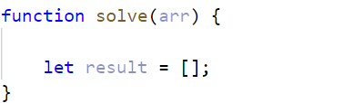

* You can use **for** loop to go around the items one by one.
* 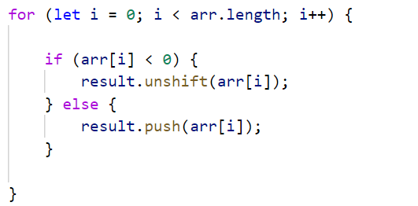If the current element is a **negative number,** you can use the **unshift()** method to add the number at the **beginning** of the array.
* Otherwise, if the current element is a **positive** number (**or 0**), use a **push()** method to add the number to the **end** of the array.
* Print on the console, each element of the array on a new line.

1. **First and Last K Numbers**

Write a function that prints the first **k** and the last **k** elements from an **array of numbers**.

The **input** comes as an **array of number** elements. The first element represents the number **k**, all other elements are from the array that needs to be processed.

The **output** is printed on the console on two lines. On the first line, print the **first** **k** elements, separated by space. On the second line, print the **last** **k** elements, separated by space.

**Examples**

|  |  |
| --- | --- |
| **Input** | **Output** |
| [**2**,  7, 8, 9] | 7 8  8 9 |
| [**3**,  6, 7, 8, 9] | 6 7 8  7 8 9 |

### Hints

* Use **slice()** to split the array into two parts

1. **Last K Numbers Sequence**

You are given two integers **n** and **k**. Write a function that generates and prints the following sequence:

* The first element is **1.**
* Every following element equals the sum of the previous **k** elements.
* The length of the sequence is **n** elements.

The **input** comes as two number arguments. The first element represents the number **n**, and the second – the number **k**.

The **output** is printed on the console on a single line, separated by space.

**Examples**

|  |  |
| --- | --- |
| **Input** | **Output** |
| 6, 3 | 1 1 2 4 7 13 |
| 8, 2 | 1 1 2 3 5 8 13 21 |

### Hints

The 2nd element (1) is the sum of the 3 elements before it, but there is only 1, so we take that. The third element is the sum of the first 2 (1 and 1), and the 4th – the sum of 1, 1, and 2. The 5th element is the sum of the 2nd, 3rd, and 4th (1, 2, and 4) and so on.

1. **Process Odd Numbers**

You are given an **array of numbers**. Write a function that prints the elements at **odd positions** from the array, **doubled** and in **reverse** order.

The **input** comes as an array of number elements.

The **output** is printed on the console on a single line, separated by space.

**Examples**

|  |  |
| --- | --- |
| **Input** | **Output** |
| [10, 15, 20, 25] | 50 30 |
| [3, 0, 10, 4, 7, 3] | 6 8 0 |

### Hints

* Counting in arrays starts from 0
* For example –we receive 10, 15, 20, 25
* The elements at odd positions are 15 (index 1) and 25 (index 3)
* We need to take these two elements and multiply them * 2
* Finally, we print them on the console in reversed order

1. **Smallest Two Numbers**

Write a function that prints the **two smallest** elements from an **array of numbers**.

The **input** comes as an array of number elements.

The **output** is printed on the console on a single line, separated by space.

**Examples**

|  |  |
| --- | --- |
| **Input** | **Output** |
| [30, 15, 50, 5] | 5 15 |
| [3, 0, 10, 4, 7, 3] | 0 3 |

### Hints

* You can use the following function to sort the numbers in the array:

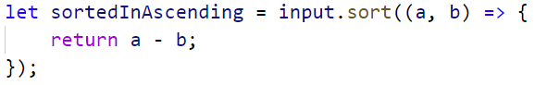

* Afterward the **first two** elements in the array are the **smallest**
* You can use **slice()** to take the first two numbers

1. **List of Products**

You will receive an **array of products**. Print a **numbered array** of all the products **ordered by name**.

**Example**

|  |  |
| --- | --- |
| **Input** | **Output** |
| ['Potatoes', 'Tomatoes', 'Onions', 'Apples'] | 1.Apples  2.Onions  3.Potatoes  4.Tomatoes |
| ['Watermelon', 'Banana', 'Apples'] | 1.Apples  2.Banana  3.Watermelon |

**Hints**

* The **sort function** rearranges the array in ascending order



* Finally, we have to **print our sorted** array. To do that we **loop through the array**

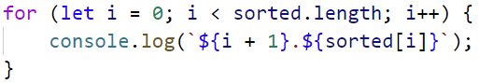

* We use **i + 1**, because we want to **start counting from 1**

1. **Array Manipulations**

Write a function that manipulates an **array of numbers**.

* **Add {number}:** add a number to the **end** of the array
* **Remove {number}:** remove **all occurrences** of a particular **number** from the array
* **RemoveAt {index}:** removes number at a **given index**
* **Insert {number} {index}:** inserts a number at a **given index**

**Note: All the indices will be valid!**

The **input** comes as an **array of strings**. The first element will be a string containing the **array to manipulate**. Every other **command** you receive will also be a string.

The **output** is the manipulated array printed on the console on a single line, **separated by space**.

**Example**

|  |  |
| --- | --- |
| **Input** | **Output** |
| ['4 19 2 53 6 43',  'Add 3',  'Remove 2',  'RemoveAt 1',  'Insert 8 3'] | 4 53 6 8 43 3 |
| ['6 12 2 65 6 42',  'Add 8',  'Remove 12',  'RemoveAt 3',  'Insert 6 2'] | 6 2 6 65 42 8 |

**Hints**

First, we receive the whole input:



* After that we take the **first** element from the commands and **convert** it to an **array of numbers**:

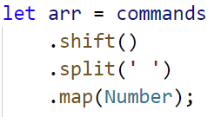

* Then we loop through the commands array, obtain each element from the command, and cast both numbers. This event is called [destructuring](https://developer.mozilla.org/en-US/docs/Web/JavaScript/Reference/Operators/Destructuring_assignment):

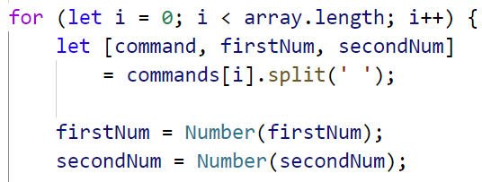

* We check if the command is equal to one of the given: "**Add**", "**Remove**", etc. 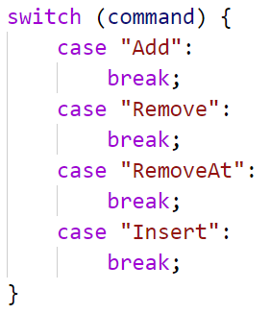
* To add an element at the end, use **push()**

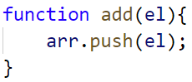

* To remove **all occurrences** of a particular element from the array, you can use **filter()**

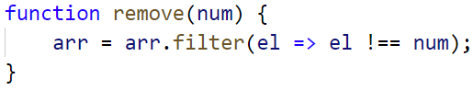

* To remove or insert at an index, you can use **splice()**

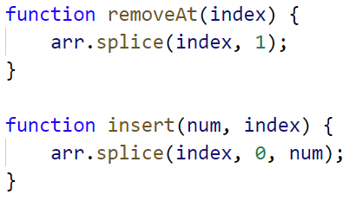

**Note:** Removing elements with **splice()** receives two parameters:

* Start Index
* Count of elements you want to remove

**Note:** Inserting elements with **splice()** receives three parameters:

* Start Index
* Count of elements to remove – if none enter 0
* Elements to insert at that position